SR-71-R

Copyright © 2019 – Blake Christensen

Version 1.2.0

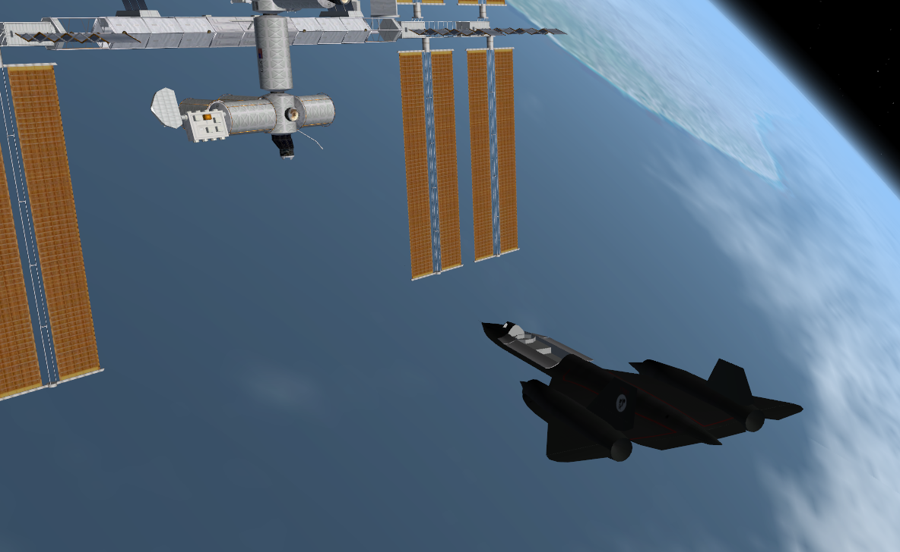

Contents

Introduction 3

Installation 3

Sample Scenarios 3

Things to be Aware Of 3

Electrical Power 3

External Power 4

Fuel Cell 4

Distribution 4

Power up Procedure 5

Atmospheric Flight Instruments 5

Attitude Indicator 6

Horizontal Situation Indicator (HSI) 6

Altimeter 7

Vertical Speed Indicator (VSI) 7

Airspeed Indicator 7

Angle of Attack Indicator (AOA) 8

Triple Display Indicator (TDI) 8

Elevator Trim 8

Power 8

Air Brake 8

Fuel System 9

Fuel Gauges 9

Filling the Fuel Tanks 9

Dumping Tanks 10

Auxiliary Power Unit (APU) 10

Hydraulic System 10

Landing Gear 10

Flight Control Surfaces 11

Cryogenic Tanks 11

Filling the Cryogenic Tanks 11

Auto Pilot 12

Doors 13

Cargo Bay 13

Canopy 13

Hover Doors 13

Retro Doors 13

Cockpit Shutter 13

Heads up Display (HUD) 13

Reaction Control System (RCS) 13

Orbital Auto Pilots 13

Lights 14

Clock/Stop watch 14

Keyboard Shortcuts 14

Procedures 15

Powered Re-entry 15

Theory: 15

Walkthrough: 15

Mission to ISS 17

Scenario 0 – Cold Start 17

Scenario 1 – Power up 17

Scenario 2 – Setup Flight 17

Scenario 3 – Ready for Takeoff 17

Scenario 4 – Chasing down the ISS 17

Scenario 5 – Rendezvous with ISS 18

Scenario 6 – Docked at the ISS 18

Scenario 7 – Lined up for re-Entry 18

Scenario 8 – Landing Approach 18

# Introduction

The SR-71-R is a fictional space plane based on the Lockheed SR-71 Blackbird. While effort has been put into keeping the flavor of the Blackbird, the original was never designed to fly into space. As a result, the systems in the SR-71-R do not simulate, or even pretend to simulate those of the original Blackbird.

The goal of the SR-71-R is to create a fun and immersive Orbiter experience.

# Installation

Simply unzip the distribution file into the main orbiter directory. No additional dependencies are required.

# Sample Scenarios

Sample scenarios are in the *SR71r* scenarios folder. These scenarios represent the milestones of the basic mission of the SR-71-R development project to fly to the ISS, dock and return to earth. There is a brief description of each scenario in the *Scenarios* section of this document which describes what is going on at that point in the mission. They do not describe in details the mechanics of orbit insertion, plane alignment, docking etc. These are generally the same for the SR-71-R as for any other vessel in Orbiter. Some specialized procedures are described here—or will be.

For version 1.0 there is an additional *Moon* folder with scenarios that mark the milestones of a flight to the Moon.

# Version 1.0

* Implement hover engines.
* Implement retro engines.
* Include Moon scenarios.
* Orbiter 2016 support.

# Version 1.1

* Reworking of Virtual Cockpit.
* Integration of Auto Pilot and Flight Computer.

# Things to be Aware Of

* The docking port is not centered on any axis. You will not be able to dock with a rotating space station (unless you are really good).
* Although damage and life support have not yet been implemented, if you lose power, or run out of fuel for the APU you will not be able to fly the SR-71-R.

# Electrical Power

The SR-71-R has a single 28 volt power bus. The bus is powered from one of three sources; external power if available (landed or docked), an emergency backup battery, and a fuel cell. The standard SR-71 was powered by two Pratt and Whitney turbojet engines, which in turn powered two generators that provided electrical power to the plane. The ‘R’ model does not have such engines and therefore does not use generators for power.

## 

1. Main power switch.
2. External power tie in.
3. Fuel Cell tie in.
4. Avionics power switch.
5. Canopy power switch.
6. Cargo power switch.
7. Fuel Cell power switch.
8. AMPS/VOLTS gauge.

## External Power

When external power is available, the ‘AVAIL’ light next to the ‘EXT BUS’ switch will be illuminated. Switch ‘EXT BUS’ ON to tie the external power into the main bus (the yellow light will illuminate).

With the main bus powered switch the ‘MAIN’ power switch ON to power the bus. External power is assumed to be available whenever the vessel is landed or docked to another vessel.

## Fuel Cell

The fuel cell produces power by drawing oxygen and hydrogen from the cryogenic tanks. When the fuel cell is operational the ‘AVAIL’ light next to the ‘F/C BUS’ switch will be illuminated. Turn the ‘F/C BUS’ switch ON to power the main power bus from the fuel cell.

The main bus must be powered to start up the fuel cell. This is generally done while landed and connected to external power.

With the main bus powered, switch ‘FUEL CELL’ ON to enable the fuel cell.

## Distribution

The bottom row of the power panel determines how the main bus is powered. When landed and the external ‘AVAIL’ light is illuminated, the ‘EXT BUS’ switch should ON to power the main bus and the ‘F/C BUS’ switch should be OFF. When ready for flight (and the fuel cell is running) switch ‘F/C BUS’ ON and switch ‘EXT BUS’ OFF.

## Power up Procedure

1. Landed or Docked, the ‘EXT BUS’ ‘AVAIL’ light is illuminated.
2. Set ‘EXT BUS’ switch ON.
3. Set ‘MAIN’ power switch ON.
4. Set ‘FUEL CELL’ switch ON. Fuel cell ‘AVAIL’ light should illuminate.
5. Set ‘F/C BUS’ switch ON. Power will continue to draw from external power as long as it is available.

# Atmospheric Flight Instruments

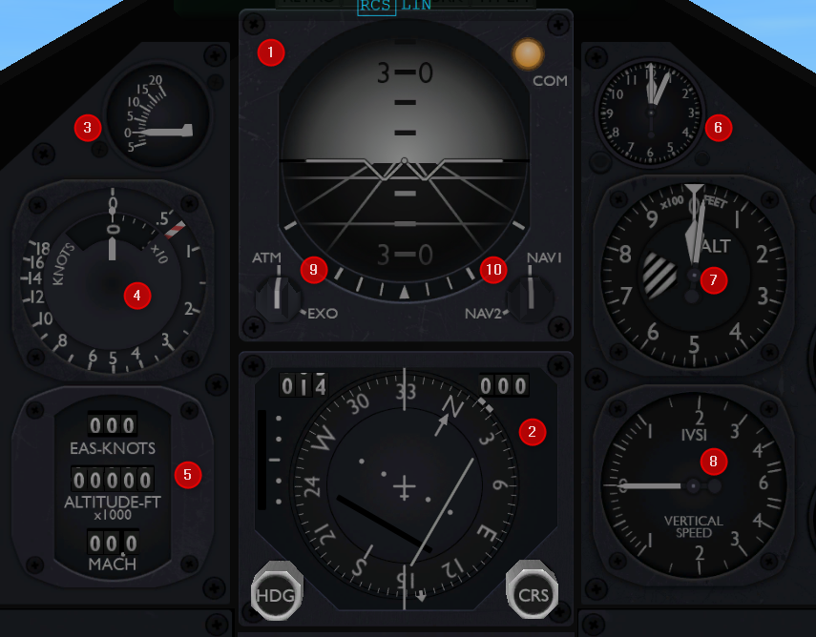

1. Attitude Indicator
2. Horizontal Situation Indicator (HSI)
3. Angle of Attack Indicator (AOA)
4. Airspeed Indicator
5. Triple Display Indicator (TDI)
6. Mission Time / Stopwatch
7. Altimeter
8. Vertical Speed Indicator (VSI)
9. Avionics mode select
10. Navigation Radio select

Several of the avionic instruments have two modes: Atmospheric (standard) and Exo-Atmospheric. The mode is controlled by the Avionics Mode selector. Where applicable both modes are described below.

Attitude Indicator

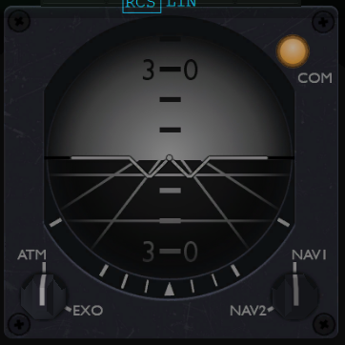

Displays pitch and bank of the aircraft.

## Horizontal Situation Indicator (HSI)

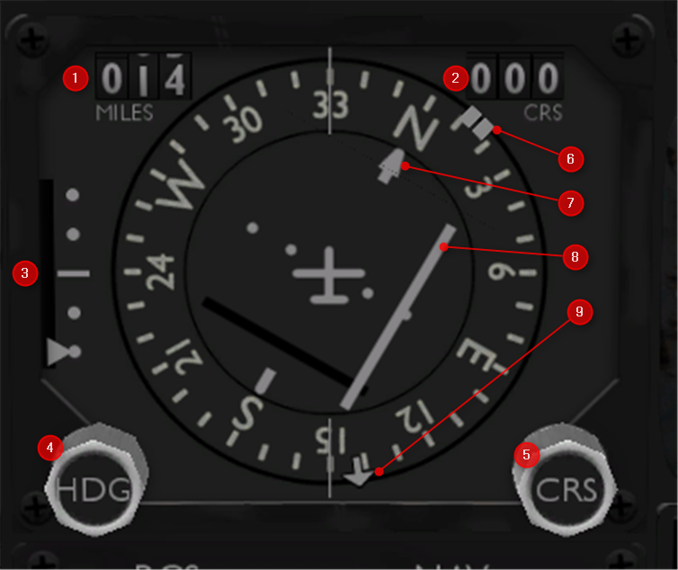

1. Distance in miles to the selected navigation signal.
2. Currently selected course.
3. Glideslope indicator.
4. Heading select knob.
5. Course select knob.
6. Heading bug.
7. Course arrow
8. Course deviation bar.
9. Bearing indicator to the currently selected navigation signal.

The HSI also supports an Exo-Atmospheric mode.

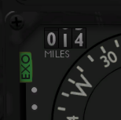

The ‘EXO’ flag will indicate when the HSI is in Exo-Atmospheric mode. The difference is the course arrow (7) will now indicate the vessel’s prograde motion in the horizontal plane. This, along with the bearing indicator (9) will help you line up with a base on approach.

## Altimeter

Displays the altitude in feet. The range is 0 to 100,000 feet.

In Exo-Atmospheric mode the altimeter will show the ‘GND’ flag indicating the altimeter is operating more like a ground radar. This is useful for landing with hover engines on a pad.  
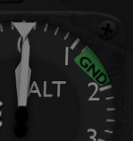

## Vertical Speed Indicator (VSI)

Displays the vertical speed of the aircraft. Range is +/- 6000 feet per minute.

## Airspeed Indicator

Aircraft speed indicator shows Mach speed in the outer ring and knots (KIAS) in the inner cutout. Maximum Mach speed for a given altitude is displayed by the red/white ‘barber pole’ indicator. Exceeding this speed will illuminate the *overspeed* light on the message panel.

In Exo-Atmospheric mode the MACH ring will show Velocity * 100. So the following display is a velocity of about 1.6k

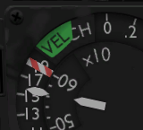

## Angle of Attack Indicator (AOA)

Displays the angle of attack of the aircraft.

## Triple Display Indicator (TDI)

Displays from top to bottom: KEAS (knots equivalent airspeed), Altitude in feet x 1000, and Mach number.

## Elevator Trim

Displays the current elevator trim setting.

## Power

Power to the atmospheric flight instruments is controlled by the ‘AVION’ switch on the power panel. The atmospheric instruments can be turned off when not needed (such as during orbital flight) to extend the fuel cell life.

# Air Brake

The inner elevons will split to create an air brake when activated. The air brake control is located on the left lower instrument panel below the gear control.

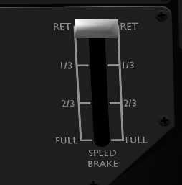

The air brake has four settings; Retracted, 1/3, 2/3, and full. Clicking on the bottom [FULL] of the control will increase the air brake one setting while clicking on the top [RET] will decrease the air brake one setting. You can also increase the air brake by pressing CTRL-B and decrease by pressing SHIFT-B.

# Fuel System

The SR-71-R holds 80,000 lbs of ‘Delta Glider’ fuel. This fuel allows us to fly into orbit and return on a single tank of gas.

## Fuel Gauges

The fuel gauges on the main panel show the quantity in pounds for the main fuel supply (left gauge), the RCS fuel supply (right gauge) and the current fuel flow from the main tank.

The auxiliary power unit (APU) also draws fuel from the RCS tank, so it should be enabled only when needed.

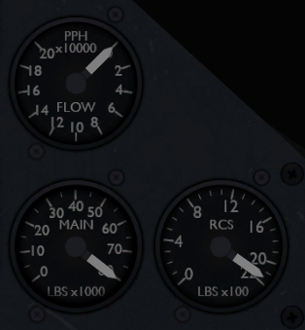

## Filling the Fuel Tanks

When the vessel is landed and stopped, or docked, we assume there is an external source of fuel available. When fuel is available the blue *Supply* light under the *Fuel Valve* button will illuminate.

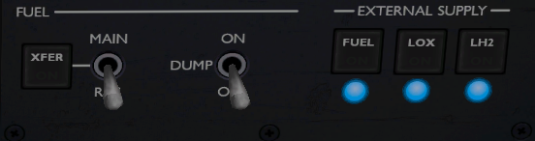

Press the *Fuel* fill valve button to open the valve to fill the main fuel tank. The RCS tank is filled by transferring fuel from the Main tank to the RCS tank. When the main tank has more than about 9000 lbs of fuel you can begin transferring fuel to the RCS tank by setting the *Transfer Main/RCS* switch to *RCS* and then set the *Transfer ON/OFF* switch to *ON*. Turn the *Transfer* switch *OFF* when the RCS tank is full. You can do this while the main tank is filling.

## Dumping Tanks

You can dump from the main tank by setting the *DUMP MAIN* switch to *ON*. This will dump fuel from the main tank until it reaches a level of about 9000 lbs. Dump the RCS tank by setting the *TRANSFER* switch to *MAIN* and setting the *TRANSFER ON/OFF* to *ON*. This will transfer the RCS fuel to the main tank where it can be dumped overboard.

# Auxiliary Power Unit (APU)

The Auxiliary Power Unit (APU) draws fuel from the RCS fuel tank to drive the airplane’s hydraulic system. When the landing gear or main flight surfaces are not needed, such as during orbital flight, the APU should be turned off. The ‘APU’ switch is on the left control panel above the hydraulic pressure indicator.

## Hydraulic System

The hydraulic system powers the main flight control surfaces and the landing gear. The hydraulic pressure gauge is on the left panel and should read 2000 psi when the APU is operating. This means power is available for the landing gear and the main atmospheric flight control surfaces.

## Landing Gear

The landing gear is operated from the landing gear lever on the left panel. Click on the handle to move the landing gear up (stowed) or down (extended). The [GEAR] light on the message panel will illuminate yellow while the landing gear is in motion, and white when the landing gear is fully extended.

The landing gear is hydraulically operated, so the APU must be running and the hydraulic pressure must read 2000psi in order to operate.

## Flight Control Surfaces

The flight control surfaces are the airplanes rudders, ailerons and elevators. These surfaces are hydraulically operated, so the APU must be running and the hydraulic pressure must read 2000psi in order to operate.

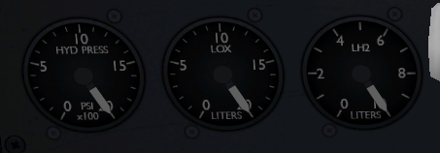

# Cryogenic Tanks

The airplane has two cryogenic tanks, one for oxygen and one for hydrogen. The fuel cell draws from both the oxygen and hydrogen tank, while the life support system draws from the oxygen tank.

## Filling the Cryogenic Tanks

The cryogenic tanks can be filled when the vessel is landed and not moving or docked with another vessel. When liquid oxygen and hydrogen are available the supply lights under their respective *FILL VALVE* buttons will illuminate. Press the valve *OPEN* button to fill the cryogenic tank. The valve will close when the tank is full.

# Auto Pilot

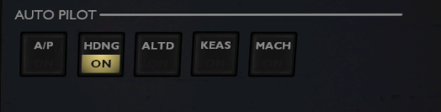

The auto pilot provides simple hold functions for heading, altitude and speed.

The ‘HDNG’ mode will follow the heading bug on the HSI display. This can be changed with the ‘HDG’ knob.

The ‘ALTD’ mode will hold the airplane at the current altitude when ON.

The ‘KEAS’ and ‘MACH’ modes will hold the current speed in KEAS or MACH number. Only one of these modes is available at a time.

The ‘A/P’ turns Auto Pilot on or off. When ON the selected modes will be active. For a give mode to be active it must be enabled ON and A/P must be ON.

# Doors

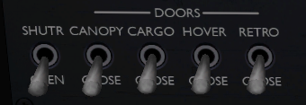

## Cargo Bay

To open or close the cargo bay, power the cargo by setting the ‘CRGO’ switch ‘ON’ (up) on the power control panel. Then use the ‘CRGO’ switch on the lower left [DOORS] control panel to open or close the cargo bay.

## Canopy

To open or close the canopy, power the canopy by setting the ‘CNPY’ switch ‘ON’ (up) on the power control panel. Then use the ‘CNPY’ switch on the lower left [DOORS] control panel to open or close the pilot canopy.

When not needed, switch the cargo and canopy power switches OFF to prevent inadvertent opening and closing.

## Hover Doors

Open hover doors using the ‘HOVR’ switch on the lower left [DOORS] control panel. The hover doors do not have a separate power switch.

## Retro Doors

Open the retro rocket doors using the ‘RTRO’ switch on the lower left [DOORS] control panel. The retro rocket doors do not have a separate power switch.

# Cockpit Shutter

The cockpit shutter is used to ‘black out’ the cockpit. This can be useful for practicing instrument flying.

# Heads up Display (HUD)

The heads up display is controlled from the ‘HUD’ switch on the main control panel. It provides the three basic orbiter HUD modes; Orbit (ORB), Surface (SURF), and Docking (DOCK). The main power switch must be ON for the HUD to operate.

# Reaction Control System (RCS)

The Reaction Control System (RCS) is controlled from the RCS switch right below the HIS. The standard orbiter hot keys work; CTRL-/ to enable disable RCS, and ‘/’ to toggle the mode.

# Orbital Auto Pilots

The standard orbital auto pilots are enabled from the buttons below the RCS knob.

# Lights

The lighting control panel is on the left bottom panel.

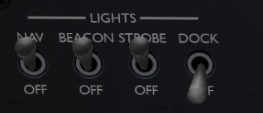

Currently Navigation (NAV), Beacon (BCN) and Strobe (STRB) lights are implemented. The main power bus must be on for any of the lights to work.

# Clock/Stop watch

The flight clock sits to the right of the attitude indicator.

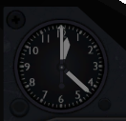

It has two primary functions; elapsed mission timer and stop watch. The standard hour and minute hands are the main elapsed timer. The elapsed timer can be reset by pressing the lower left button. This should be done at the start of a mission.

The other functions is a stop watch. These are the other two hands on the clock. The long skinny hand is the seconds, and the smaller arrow head hand is the minutes. The upper right button will start, stop and reset the stop watch function.

# Keyboard Shortcuts

[g] - Landing gear.

[Ctrl]-[1] - Toggle throttle limiter.

[1] - Main auto pilot toggle on/off.

[2] - Toggle hold heading.

[3] - Toggle hold altitude.

[4] - Toggle hold speed.

[5] - Toggle speed hold mode Mach-Keas.

[Ctrl]-[b] - Increase air brake.

[Alt]-[b] - Decrease air brake.

# Procedures

## Powered Re-entry

Based on Scenario 7 – Lined up for re-entry.

[Note: The general theory holds, but this description needs to be updated for version 1.0]

### Theory:

We are going to re-enter the earth’s atmosphere flying backwards. As we burn to slow our speed, our velocity vector will move down below our vessel towards the surface. We will use the RCS controls to maintain the vessel in a retrograde, upright, wings level orientation until the nose is at about 70 degrees. We will maintain that orientation until we are into the atmosphere. By maintaining that orientation, the velocity vector will eventually move in front of the ship and allow us to transition into normal flight.

### Walkthrough:

At the start of this scenario you are a little over one orbit from Cape Canaveral. On the map MFD click ‘TRK’ so you can see where your vessel is, then accelerate time until you are off the coast of Central America, about 3.0M Dst on the Map MFD from our target. You may want to be in *nose-down* mode ([CTRL][ALT][UP]) to better see the Map MFD at this point.

Re-entry checklist:

- Throttle Limit set FULL.

- Auto Pilot MAIN, HDG, ALT, ATT set to OFF. SPEED set to ON and the KEAS/MACH switch set to KEAS.

- Power: AVION set ON, CNPY and CRGO set OFF.

- HUD set to SURF mode.

- RCS set to ROT mode.

- APU set ON. Confirm Hydraulic Pressure.

- Right MFD select COM/NAV mode. Set NAV1 to 134.20, ILS for Cape Canaveral runway 33.

- Set CRS to 33 on the HSI. This is our runway heading.

Re-Entry:

- At about 2.0M Dst on the Map MFD initiate the retrograde auto pilot (RTF-G).

- When in retrograde position, turn off the retrograde auto pilot and use the RCS to rotate into an up-right, wings level position. Your attitude indicator should look like this: 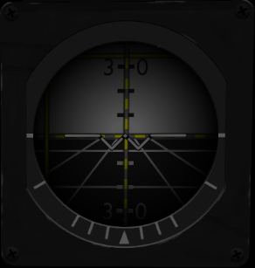

- Use the RCS controls to maintain the retrograde cross hairs on the attitude indicator ‘W’ mark.

- At about 1.2M Dst on the Map MFD begin your re-entry burn. Full throttle. Sit up in the cockpit to get a better view ([CTRL][ALT][DOWN])

- Position your view so that you can see the Velocity [V#] readout on the HUD at the top or your screen and your position on the Map MFD at the bottom. They will depend on your screen size, but we want to see both our speed indicator and the velocity of our vessel from the HUD.

- As your speed is reduced, the velocity vector will begin to dip down toward the surface, you will see the horizontal bar on the attitude indicator rise. Use your RCS controls to compensate (keys 8 and 9 on the keypad).

- When the velocity indicator is at about [V1000] we want to start throttling back. We don’t want to slow down too soon. Keep the velocity at about that range until about 400,000 feet (400 on the TDI). The Mach meter will be at about 2.0. After this point you will see the Mach indicator begin to rise. Increase throttle to compensate, try to keep your speed at about 2.2 Mach.

- We also want to watch the attitude indicator. When it reads about 70 degrees nose-up we will stop chasing the retrograde bar. We want to stay at about 70 degrees until we are in the atmosphere.

At 300,000 feet things start to happen fast. You will need the KIL ROT auto pilot to hold 70 degrees. Your speed will begin to increase and you will need full throttle again to control it. The velocity vector is working its way underneath and slowly in front of your vessel. At about 90,000 feet it will give up and the nose will begin to drop. Disable KILL ROT and reduce your throttle. Begin flying the vessel (hopefully you have a joystick for this part).

The most important thing to do at transition is to establish level flight. A drop in altitude will likely result in ‘overspeed’ and stressing of the aircraft.

When level, adjust the throttle until you at about 300 KEAS on the TDI. At that point hit [1] to enable the auto pilot. We have it preset to run the KEAS hold program. Now use the trim controls ([Insert][Delete] keys) to set a slow steady descent. Take your hand off the joystick and relax.

Where are we?

Determine the bearing to the runway and adjust the ‘HDG’ bug to take us there. When set, hit [2] to turn on the ‘Hold Heading’ auto pilot.

By holding our KEAS speed steady as we descend, we will keep our Mach speed below the max-Mach speed while still reducing our velocity. You can keep the speed hold auto pilot enabled until final approach if you wish.

The HSI is setup for a landing at runway 33. The hard part is over, all you need to do now is land.

# Mission to ISS

The following scenarios are milestones in the primary development mission of flying to the ISS, docking, then returning and landing. Takeoff and landing are at Cape Canaveral.

## Scenario 0 – Cold Start

The scenario begins with the vessel parked on runway 33 at Cape Canaveral. Main fuel, RCS fuel and the cryogenic tanks are completely empty. We need to fill the Main and RCS fuel tanks as well as the cryogenic tanks.

## Scenario 1 – Power up

The scenario begins with the vessel parked on runway 33 at Cape Canaveral. Main fuel, RCS fuel and the cryogenic tanks are topped off and the power system is off. The cargo bay doors and the pilot canopy are open.

## Scenario 2 – Setup Flight

The scenario begins with the plane powered up and the cargo bay and canopy closed. We now need to setup the flight systems for our flight. The ISS is at an inclination of 74.51, and we are located at Cape Canaveral (28.60 latitude) so our take off heading is about 17.7. You can enter that in the HSI [HDG] knob and use the ‘Heading’ auto pilot if you want.

## Scenario 3 – Ready for Takeoff

The scenario begins with the plane powered up and configured for our flight to the ISS. We will takeoff and ascend into orbit and establish an orbit at about 365 kilometers. Watch your Mach speed on the speed indicator so that you don’t go to fast before you have gained enough altitude. Rotation speed in the SR-71-R is about 280-300 knots.

## Scenario 4 – Chasing down the ISS

The scenario begins with our orbit established. The next task is to rendezvous with the ISS. To do that you will need to align planes with the ISS (Align Planes MFD) and sync up with the ISS orbit (Sync Orbit MFD).

## Scenario 5 – Rendezvous with ISS

The scenario begins with our vessel in the vicinity of the ISS. Actually it is about 4000 meters and closing. You will need to null out the velocity difference and begin lining up for docking.

## Scenario 6 – Docked at the ISS

The scenario begins docked at the ISS. You should have external power available, so if you are going to be awhile, turn off your fuel cell to save Oxygen and Hydrogen.

## Scenario 7 – Lined up for re-Entry

The scenario begins with our vessel one orbit out from Cape Canaveral. We used the Map MFD to adjust our ground track so that we will fly right over the Cape. Turn retrograde and ease yourself back into the atmosphere. Careful not to ‘overspeed’.

## Scenario 8 – Landing Approach

The scenario begins with our vessel approaching Cape Canaveral from the south. ILS for runway 33 has been entered into the COM MFD. Watch your glide slope and course on the HSI.